Tutorial 2

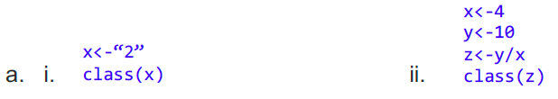

Character Numeric

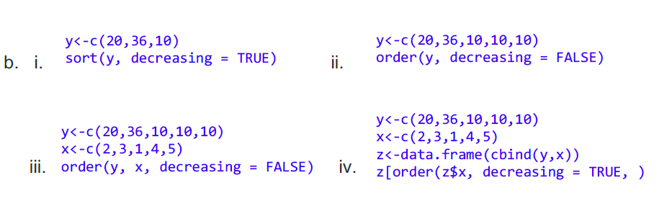

36,20,10 3,4,5,1,2



y x

10 5

10 4

36 3

20 2

10 1

3,4,5,1,2 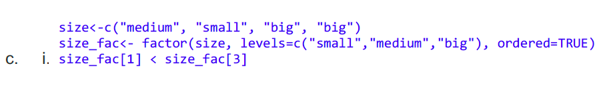

TRUE

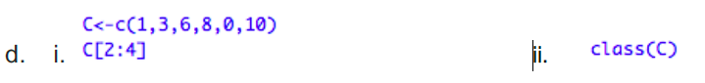

3,6,8 Numeric



Character



Numeric 6,8,10



Numeric d

e

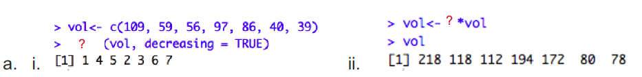

Order 2

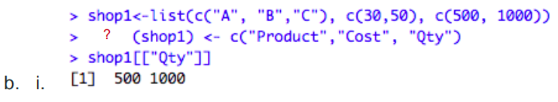-

Names

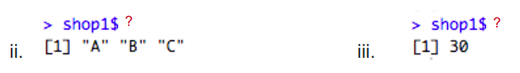

Product Cost[1]

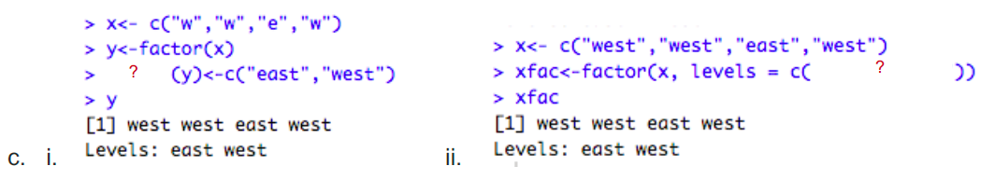-

Levels "east","west"

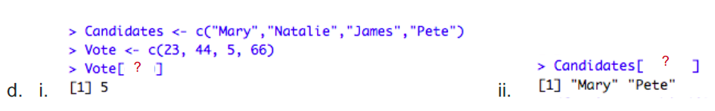

3 c(1,4)

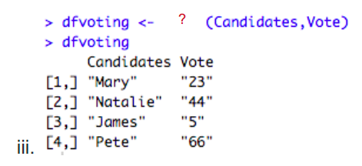

data.frame

cbind

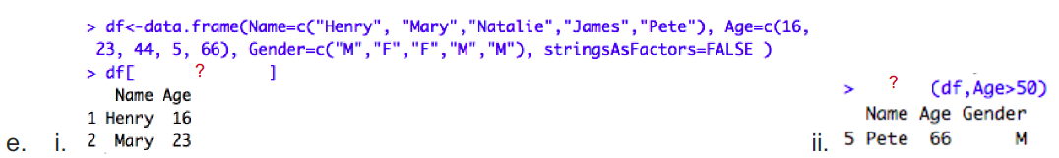

c(1,2),c(1,2) subset

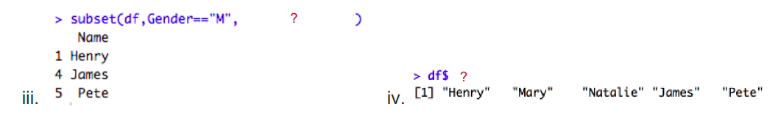

1. Name

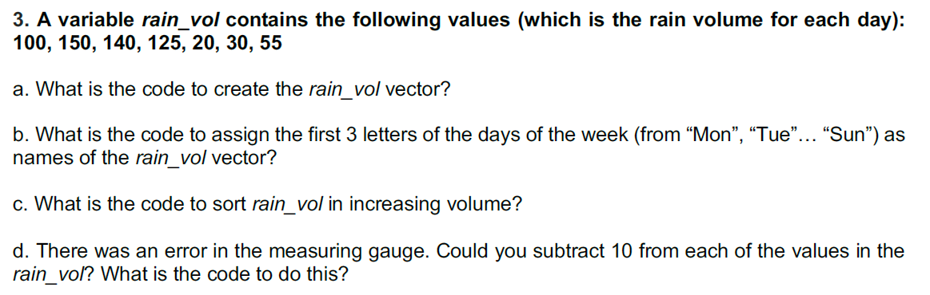

1. rain_vol <- c(100,150,140,125,20,30,55)
2. names(rain_vol) <- c(“Mon”,”Tue”,”Wed”,”Thu”,”Fri”,”Sat”,”Sun”)
3. sort(rain_vol)
4. rain_vol <- rain_vol - 10